GE M01 Language Fundamentals and Tools

Points: 25 (See Rubric in Canvas)
Due Date: Due date listed in Canvas but some sections will be due as class participation before the final due date. Create Calendar reminders
- Final submission will be accepted up to 24 hours after the due date with a 10% penalty. Meaning if you turn it in at 12:01 am of the next day you will be deducted 10% of the total points from your score.
- If the assignment is more than 24 hours late, it will be a 0.
Submission: Upload files separately and do not upload a zip file.
- Two Document Files as PDF or Word document: This document with your answers in the highlighted areas unless otherwise stated and Technical Document
- Two Java Files (. java files NOT CLASS FILES): Code from
  - 2.1 Explore GuessNumber Code
  - 2.2 Calculate Grades
Objectives:
- Analyze and apply module 01 concepts
- Develop effective technical documentation to demonstrate your understanding of technical concepts, with a focus on clarity and professional presentation.
- Apply version control and debugging practices using Eclipse and GitHub.

Effort: You are encouraged to collaborate to discuss concepts and explore writing code together. Remember
- Review lectures and links in the lectures to information first.
- Follow CS Academic Integrity and AI Policy - Harding
- If you find you don’t understand the information in the lecture reach out to Deb, Elaine or Heriberto

If you download this as a word document and you have any problems typing your answer in the tables you must click on 3 dots and remove content control.
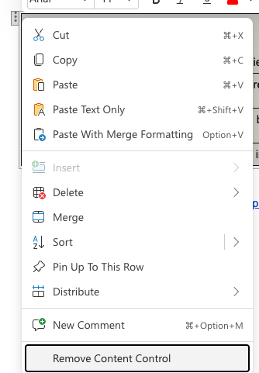

Part 0 Learning and Collaborating Reflection
0.1 Working on Teams
0.2 Learning How to Learn
0.3 Algorithms
Part 1: Technical Document Explore and Explain
Part 2 Analyze and Apply
2.1 Explore GuessNumber Code
2.2 Calculate Grades
3 Reflection

Part 0 Learning and Collaborating Reflection
The reality of computer science is that there are so many languages, technologies and methodologies available and it is constantly evolving with new ones. So the goal is not just to understand the current technologies but developing skills to learn any new technology.

0.1 Working on Teams
In this course, we’ll work together on in-class activities, labs, and discussions. Good collaboration isn’t just about dividing work — it’s about building understanding together. Read 10 Collaboration Skills Examples and answer the following

1. Pick two of the 10 skills that you think are strengths you bring to a team and why.
Adaptability/Resilience
2 Pick two of the 10 skills you think are most difficult for you and something you can do to try and improve in that area this semester.
Active listening/Conflict resolution

0.2 Learning How to Learn
Learning how to learn is an important component of this course as your career will be full of learning something new. One of my favorite websites is Train Ugly - How To Get More Out Of Your Practice.

1 Listen to this 30 minute podcast Desirable Difficulties - The Learner Lab and answer the following.

Explain desirable difficulties and how you think it relates to the learning in this class and in your future career.
Desirable difficulties are essentially the fundamental challenges that need to be present to increase one's capability or understanding of a subject a desirable difficulty in a coding class would be understanding A New Concept via running into multiple errors and having to delve further into research on how exactly the New Concept functions.

2 Read Bluesky CEO Jay Graber warns: If you're a student, using AI means where Bluesky CEO’s Jay Graber warns that over-reliance on AI can impair critical thinking and long-term skill development and may contribute to “academic obsolescence” - declining ability to perform without AI

What skills do you risk losing if you depend on AI too much?
Critical thinking skills and problem solving Solutions if no real challenges present and you can ask a ( normally very faulty tool might I add) for Solutions then your brain doesn't have the opportunity to grow develop and continue to innovate
3 Summarize 3 Strategies you will use this semester to build skills, become a lifelong learner, and Use AI Tools in a way that supports your own thinking.

collaboration , adaptabblilty, conflict resauton I will work on my collaboration ability to make sure I can properly network with people that may understand technicalities of coding that I don't or just generally ask for assistance when I need it as well as seek out new opportunities to learn
adaptability for when I am having trouble with any given program in using what resources I have available to me to overcome that obstacle
conflict resolution to help me develop my understanding of what information to get when a conflict arises and how to properly communicate that to others so that what ever issue comes up can be resolved

0.3 Algorithms
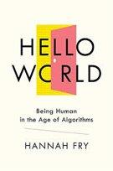
"You can’t just build an algorithm, put it on a shelf and decide whether you think it’s good or bad completely in isolation. You have to think about how that algorithm actually integrates with the world that you’re embedding in." Hannah Fry

Read Chapter 1 from Hannah Fry, “Hello World, Being Human in the Age of Algorithms” and answer the following.

Answer the following in your own words.
1. Describe an algorithm.
I think the best way I can describe algorithms is an analogy they work like a sponge they soak up whatever is present regardless of whatever is present Maybe the repository of what is stored can be used later but altering it would require an in-depth process that may be more work than most want to do I can see it being a useful tool but I'm also concerned that the implications of using something so indiscriminate for larger scale processes that may need to be more pick and choosy with the data they absorb and use as reference especially if an algorithm is being used for a user interface if not every user is considered then it raises concern about intentionally or unintentionally blocking off access to some users

2. Summarize the four main categories of real world tasks that algorithms are doing.

The first of the four would be prioritization essentially the PEMDAS of the four categories it has a logical understanding of what it needs to put first based on a preset disposition of what task is most important and then goes down the list in order.
next up would be classification taking the data presented in assigning value that the computer can understand and then later use To organize and store new data
After that would be Association taking a look at the data and then finding connections between that might be valuable or important to understand for later processing / Development of classification
And then last but not least would be filtering after categorically organizing all present data figuring out what is important to reference back to or Mark is viable for future use will also understanding what can be flagged as irrelevant and discarded
3. Explain the two main approaches taken by algorithms. Include the pros and cons.

The two main approaches are rule based and Machine learning algorithms rule based has very specific set logic core like repeating the same set of instructions to complete a task over and over again however machine learning is more ambiguous specifically for the purpose of absorbing data to develop on its own without a preset guideline in place in other words how humans learn. Both of these have their own sets of pros and console let's start with rule based algorithms rule based algorithms work great for things like automation you have a set of rules that you don't need to divert from because the ultimate end goal is supposed to be the same every single time without fail however in the event that the rules are flood from the beginning or another part of the interface with the algorithm isn't working say in an assembly line a machine stops working and the algorithm continues to try to function per normal you will eventually run into the issue of not getting the result you initially wanted due to the lack of adaptability in the algorithm itself machine learning can theoretically adapt but in practice not nearly as fast as humans additionally if the data that the machine is using to learn is incorrect itself you then have a more complex version of the problem initially presented with rule based algorithms the issue with both is that they don't work as blend all solutions to things like automation or removing the human factor from existing jobs They work great as assistants to a system being overviewed by humans but left to their own devices are highly inefficient and extremely vulnerable to manipulation from a variety of factors
4. What can happen when we only rely on machines to make decisions for us?
The biggest and most pressing issue is that we lose the point of algorithms in the first place, the point of developing these algorithms and developing technology further is to assist Humanity in existing as itself our bodies are not perfect machines and need external help which is where algorithms can be very helpful but If we instead use algorithms as the whole solution instead of just part of it we lose a variety of factors our ability to think critically, understanding of algorithms and our ability to run maintenance on them as they develop and most important Our agency over the tasks these Algorithms were originally designed to do. Algorithms do not have the new ones that comes with Human Experience and critical thinking of course there is always the option to develop more complex algorithms to compile a more diverse set of options but in the end any type of algorithm will always lack the human form of adaptability That is needed for the tasks they perform.

Part 1: Technical Document Explore and Explain
Purpose: Professional communication to demonstrate your learnings by connecting different ideas from lectures or provided resources.
- Clearly explain key ideas in your own words and include supporting evidence such as code examples, images, screenshots, or charts.

You will update your technical document to have it as a resource for your projects, quizzes, future reference and resume.
- Tech Doc CS1050: Download as word or create a copy of the google documentation.
  - Put in your git repository after you set up git and github.
  - Submit this as a word or pdf with your GE submission.
- Use headings to organize topics and create or update a table of contents to be able to quickly access information.
  - Headings, Subheadings, and Table of Contents (Google Docs)
  - Headings, Subheadings, and Table of Contents (Microsoft Word)
- Complete these sections
  - Module 1: Programming Fundamentals and Tools all objectives
  - Version Control
  - Implement Quality Documented Code
    - Apply Java naming conventions for variables, constants, methods, and classes.
    - Write comments at top of file and inline comments to document code.

Part 2 Analyze and Apply
Demonstrates a clear analysis of a problem and applies relevant concepts effectively. Work shows independent thinking and understanding. You will use Git, GitHub and Eclipse to edit, version and back up your code.

Resources to get started with Git/GitHub and Eclipse
- Git and Github Version Control
- Setup Eclipse - Download and put in your github Resources Folder
- Eclipse Cheat Sheet - Download and put in your github Resources Folder

2.1 Explore GuessNumber Code
Be curious about the code as you explore. Come to office hours if you need help setting up your environment to use Eclipse and Git/Github.

- Complete Interactive Animation for Guess Number Program
- Open Eclipse Cheat Sheet and follow the instructions on how to create a project called CS1050M01. Take your time because if you do it wrong it won’t work and you will need to do it over.
- Download GuessNumber.java
- Open Eclipse Cheat Sheet and read how to add an existing Java file by dragging and dropping into your CS1050M01 Eclipse project.
  - Use Visualize code in Python, JavaScript, C, C++, and Java if you do not have your environment set up. Select java and paste code so you can edit, run, add comments and step through code.
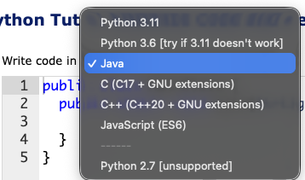
- Add comments to the parts of the code to help you understand. You can use parts of the code and comments in your technical document.
- Version your guess number and technical document locally and then back up on your github cloud server.
- Upload the .java file into GE M01 submission.

1. Take a screenshot showing you are using the debugger to show what is stored in the variable number and guess after you enter a guess.
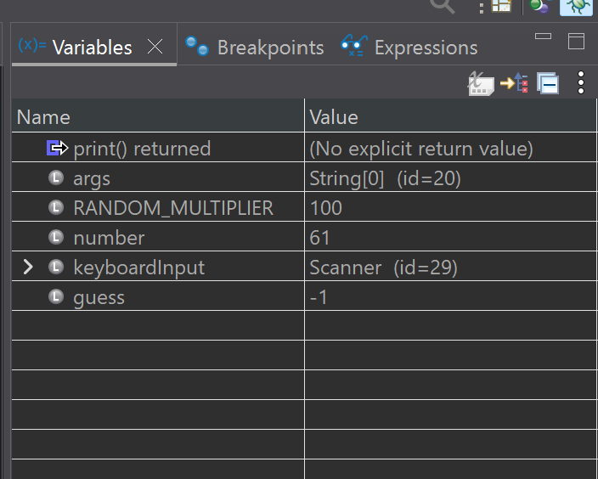

2. Describe 3 things you understand better about the code after using the debugger.
- Way variables are stored in the computer and the linear flow to the program
- More about how the scanner class works and calling a method
- Reusing different variables and why constants are useful
3. Identify the warning in the code.
Show a screenshot of the warning in the program.
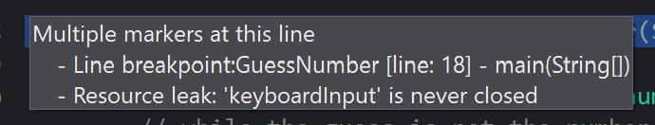
Find a resource to help fix the problem based on the warning message. You can use AI for help with syntax errors and warnings.
Keyboard input method is never properly closed which should be done inside Main and at the end of the program
4. Take a screenshot to show your GuessNumber.java file in your repo on the Github Cloud Server.
Explain why only the java file is showing in the repos and not the class file.
The driver file is the manipulatable one

2.2 Calculate Grades
You will create a project to store your assignment code and then create your program file. The program you create here will be updated in future guided explorations.

Remember: Commit and push your code often.
- Use the Eclipse Cheat Sheet to create a new class called GEM01GradeCalculations in your CS1050M01 project
- Update the code to add an initial comment. This initial comment is required on all assignments.
  - Your name
  - Class name
  - Section (M/W) or (T/R) Due date
  - Description
/*
* Name: [YOUR NAME]
* Class: CS1050 (M/W or T/TH)
* Description: Guided Exploration 01
* The program will calculate a final grade for this class based on the category weights
*/

public class LastNameFirstNameGE01Calculation
{

{

}//main

}//Class GE01

- Design your algorithm on paper. Use an example test case to use to determine how to compute a grade on paper.
  - Use constants for percentage weights and variables for your category grades and final grade. Do not hardcode values in your expression to calculate your final grade. Example of hardcoding (.15 * 95) + ( .2* 92) + ( .25* 88) + ( .2*87 ) + (.2 *93 )
  - Use correct naming conventions.

Category Weights | Example Category Grades
Class participation 15% | 95
Guided Explorations 20% | 92
Quizzes 25% | 88
Projects 20% | 87
Final Demonstration 20% | 93

- Working with Variables and Expressions: Add code to calculate your final grade.
  - Write a little code and run. Do not try and write all the code at once as this is harder to fix errors.
- Display your name and final grade using System.out.println
- Add comments to explain your code.
- Commit your .java code file locally and push your code to github remote repository. Make sure you include comments.
- Upload the .java file into GE M01 submission.

3 Reflection
1. Identify one specific challenge you faced in this exploration and what you did to overcome it.
The main issue I had with this exploration was I understood Exactly what I needed to do as one big step but was having trouble breaking it down into individual steps so that the program could run properly
2. Team Collaboration
What is one strength of yours when working with your group in class?
I'm effective at checking in with others and making sure I'm asking questions when I need to
What is one strength of your team?
Nobody was really afraid to ask questions, We all understood what we were having difficulty with and we're fully comfortable asking each other when we needed help
What is one area you would like to improve about your team working together in class?
Before addressing a problem working on how to properly identify the components of the problem in the relay them to others this is an issue I myself had and I noticed with a few others in my team
3. Environment Set Up

On a scale of 1 to 5 rate yourself on using the following tools and include one thing you understand and one thing you need help on.
5
git/github rating:
- I understand how to
I understood how to interface with get slash GitHub and both commit and push new documentation or code to its respective file
- I need help on
Remembering to properly comment On each individual push so that I have detailed cataloging of what updates were made when and why
If you are not using Eclipse include what IDE you are using
Eclipse rating:
- I understand how to
Write new programs and ensure that they are properly categorized in their module files
- I need help on
Understanding exactly how the debugger works and utilizing it as needed
4. Now that you are submitting your first Guided Exploration
- What do you wish you would have asked for help on or what did you get help on?
Most of what I needed help with was some basic fundamentals with the coding environment I understand the principles of what I was doing and And how I was making it happen but I needed to make sure that I understood the environment so that I could continue to use it in the future
- How was your time management? Did you have to do a lot the day it was due?
Time management could definitely use some work but I'm going to give myself some Grace with that given the amount of medical issues that of currently arisen
- What will you keep the same and what will you try to improve on when you do the next GE? I plan to keep asking questions but I plan on documenting my work a little bit better so that if I need to I can reference it back for future guided explorations

